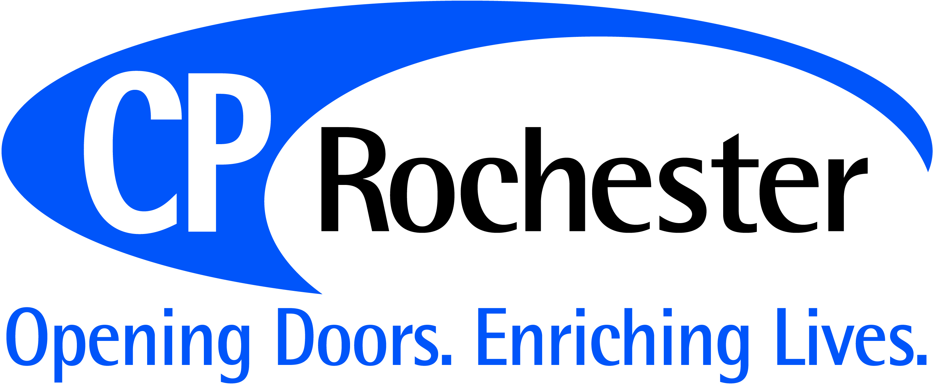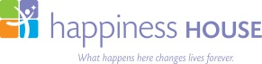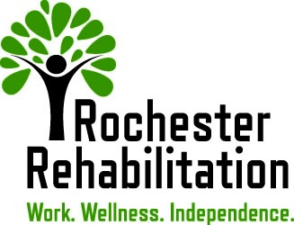

FOR IMMEDIATE RELEASE
Media Contact: Marty Jones Wallace
mwallace@happinesshouse.org
585-286-9711 x1322

Ability Partners, Inc. Named Semifinalist in 2017 Collaboration Prize

Victor, NY (February 6, 2017) Ability Partners, Inc. was named a semifinalist for the 2017 Collaboration Prize. This is a national award designed to highlight exceptional permanent models of collaboration among nonprofit organizations. One of 18 semifinalists, Ability Partners, Inc., was chosen from more than 350 submissions.

“We are very excited to learn we were one among 17 others worthy of being selected as semifinalists for the Collaboration Prize,” said Mary Walsh Boatfield, President and Chief Executive Officer of Ability Partners, Inc., CP Rochester, Happiness House, and Rochester Rehabilitation. “It is an honor to be selected from a national pool of non-profit companies for this award. The affiliation we have among our three agencies allows us to provide and coordinate a greater range of services for adults and children with disabilities in the Greater Rochester and Finger Lakes regions.”

A selection panel comprising major supporters of nonprofit collaboration will select eight finalists from the 18 semifinalists. Judges will identify eight collaborations that exemplify the impact of working together on a permanent basis. The finalists will be announced on February 23, 2017 and each will receive $10,000. The grand prize winner will receive an additional $150,000 and will be announced in April 2017.
For a full list of semifinalists, please visit www.thecollaborationprize.org.

About Ability Partners, Inc.
Incorporated in December 2014; Ability Partners, Inc. is the passive parent corporation of CP Rochester and Rochester Rehabilitation in Monroe County, and Happiness House in Ontario County. The three partner agencies operate as separate subsidiaries and employ over 700 clinical, professional, paraprofessional, and administrative individuals who live in the areas where they serve.
CP Rochester
CP Rochester was established in 1946 and provides clinical, residential, educational, and personal support services to individuals with disabilities in the greater Monroe County region.
Happiness House
Happiness House, an educational, residential, health and human service organization, has been serving adults and children with disabilities in the Finger Lakes region since 1969.
Rochester Rehabilitation
Founded in 1919, Rochester Rehabilitation operates six services in the rehabilitative areas of employment and job support, driver evaluation and training, and mental health services.
About the 2017 Collaboration Prize
The 2017 Collaboration Prize was designed to raise awareness of collaboration as a powerful and strategic way for nonprofits to increase their impact. A legacy of the Prize is the Nonprofit Collaboration Database, a resource of effective collaboration models among nonprofits. The database currently contains information on more than 650 collaborations and will expand to include new models from the 2017 Prize process. Nonprofits and other interested organizations can access the easily searchable database at www.grantspace.org/collaboration.

###

